Part I: Mission Analysis – Boiled Down
In the slotting screen, note the number of groupings, roughly how many players in each, and any support assets (helicopters, vehicles, medics).
Critically read the Situation, Mission, and “Mission Notes”.
Note key points: Objectives, Enemy Locations, Intents, Timings, and Critical Information.
Review the Execution, Service & Support, and Command and Signals.
*Stop……….think……… say to yourself ……..“SO WHAT?” throughout Step 1.*

Step 1: Terrain Analysis
Apply OCOKA to your mission looking for:
- Observation: Areas providing visibility over key terrain and enemy positions.
- Cover: Protection from enemy fire.
- Obstacles: Natural or man-made features hindering movement.
- Key Terrain: Terrain providing significant tactical advantage.
- Avenues of Approach: Routes available for movement towards objectives.
Apply FLOCARK to systematically analyze the battlespace for:
- Features: Distinct terrain elements such as ridges, hills, buildings.
- Lanes: Routes or corridors suitable for movement.
- Obstacles: Terrain features or barriers impeding movement.
- Canalizing Terrain: Terrain forcing units into predictable routes.
- Avenues of Approach: Available paths leading toward or away from objectives.
OCOKA Factor & Definition | How They Work Together | FLOCARK Factor & Definition
Observation – Areas providing visibility over key terrain and enemy positions. | Reinforces: Both identify vantage points and terrain that offers visibility; OCOKA is broader, FLOCARK “Features” is more granular. | Features – Distinct terrain elements such as ridges, hills, buildings, vantage points, natural high ground.
Cover – Natural or man-made protection from enemy fire. | Partially overlaps: OCOKA explicitly addresses protection from fire; FLOCARK “Lanes” may indirectly consider cover along routes. | Lanes – Routes or corridors suitable for movement (cover along these may be assessed here, but not explicitly in FLOCARK).
Obstacles – Natural or man-made features hindering movement. | Direct overlap: Both focus on hindrances to movement; FLOCARK lists specific types while OCOKA leaves it more general. | Obstacles – Rivers, forests, minefields, barriers, urban density, rough terrain.
(No direct OCOKA equivalent) | Adds detail: Canalizing terrain is not explicitly in OCOKA but directly relates to Avenues of Approach and Obstacles. | Canalizing Terrain – Terrain forcing units into predictable routes or choke points.
Key Terrain – Terrain providing significant tactical advantage. | Identical intent: Both highlight decisive terrain features; FLOCARK’s detail mirrors OCOKA almost exactly. | Key Terrain – Essential control points: high ground, bridges, road junctions, choke points.
Avenues of Approach – Routes available for movement toward objectives. | Direct overlap with extra detail: OCOKA gives broad movement routes; FLOCARK adds evaluation and subcategories. | Lanes – Movement corridors; Canalizing Terrain – Choke routes; Rated Avenues – Best vs. poor approaches based on mobility, cover, exposure.
- Rated Avenues: Evaluation of avenues based on mobility, cover, exposure.
- Key Terrain: Terrain providing significant tactical advantage.

Step 2: Course of Action (COA) Analysis
Based on the information so far, understand the enemy’s intent and what their objectives are to devise two outcomes:
Step 2A: Most Likely Course of Action (MLCOA) – Expected ENEMY plan based on capabilities, intent, and terrain.
Step 2B: Most Dangerous Course of Action (MDCOA) – Worst-case enemy plan that could cause mission failure. Consider the most disadvantageous action the enemy could perform to you.
*See Part I – Annex B for a Step-By-Step of developing the Enemy COAs.

Step 3: Friendly Force Considerations
Now that we have built an idea of what is happening, start ‘putting your units on the board’ as in begin your planning. There are many types of operations, but typically in all you need to understand the:
Category | Details | Notes / Implications
Disposition & Location | Higher HQ intent: Adjacent units: Supporting forces: (arty, aviation, engineers, EW, ISR) | Consider distance/time to support, mutual support, gaps.
Capabilities & Limitations | Combat power: Mobility/logistics: Fire support: | Identify strengths to exploit and weaknesses to mitigate.
Friendly COA | Scheme of maneuver: Phases: Tasks to subordinate units: Main effort / decisive ops / shaping ops: Contingency plans: | Highlight synchronization needs and decision points.
Coordination & Deconfliction | Boundaries: Phase lines: Checkpoints: Axis of advance: RFAs / NFAs / ACMs: ROE: Fratricide avoidance measures: | Ensure no interference with adjacent/supporting forces.
Command Relationships | OPCON/TACON/DS relationships: Command structure: Planned transitions: | Ensure clarity on authority for tasking/support.
Signal & Reporting | Frequencies: Call signs: Digital networks: PCC/PCI reporting: Comms maintenance: | Prep redundancy and interoperability measures.
Decision Points & CCIRs | Decision points: CCIRs: | Link directly to friendly and enemy actions/timelines.
Planning Assumptions & Risks | Assumptions: Accepted risks: | Ensure assumptions are realistic; note mitigation measures.

Step 4: Task Organization
With nearly a complete understanding (as best as possible) of the battlespace, the enemy’s intent, and the tools available, your force now needs to be ‘Task Organized’ and synchronized. This is your focus through the mission and ensuring movements happen, or are expedited, to ensure force cohesion (working together).
Break your units into elements or groupings, for example:
Element | Purpose | Assets | Notes
Assault | Seize/destroy objectives | Infantry, Breachers | Main Effort
Fire Base | Suppression/Smoke | GPMG, AT | Supporting
Security | Protection/early warning | Rifle Teams, LMG | Flanks, routes
Recon/ISR | Locate and observe | Patrol, UAV | Continuous ISR
Mortar/IDF | Indirect fire support | Mortars, FOOs | Linked via net
Engineer | Breach, demolitions | Sappers, EOD | With Assault
CSS | Logistical support | Medics, Ammo | At CSS nodes
Reserve/QRF | Reinforce/react | Infantry, APC | Trigger-based
Once elements are organized, apply them in a sequence that maximizes benefits and synchronizes phases ending when specific conditions are met. Coordinate interdependent tasks using a synchronization matrix like the example below.
Element | Phase 1 – Preparation | Phase 2 – Approach | Phase 3 – Assault | Phase 4 – Consolidate
Assault | Final rehearsals, weapon checks, coordination with Engineers | Move in covered approach lanes, maintain comms with Fire Base | Seize/destroy objectives, clear positions | Establish hasty defence, prep for counterattack
Fire Base | Position selection, cam concealment, ammo resupply | Provide suppressive fire as Assault moves | Increase rate of fire during breach, shift fire on signal | Suppress enemy withdrawal or counterattack
Security | Deploy to likely enemy avenues, establish early warning | Maintain flank and rear security during movement | Block enemy reinforcements from flanks | Continue flank/rear protection
Recon / ISR | Confirm enemy positions, identify obstacles | Update enemy movements to all elements | Provide real-time updates to Assault and Fire Base | Maintain overwatch for counterattack indicators
Mortar / IDF | Pre-register targets, confirm comms with FOOs | Fire smoke or HE to mask Assault approach | Deliver planned and on-call fire in depth | Fire defensive targets on likely counterattack routes
Engineer | Prepare breaching kit, recon obstacles | Move with Assault element | Breach wire, walls, or minefields; demolitions on target | Conduct rapid repairs or fortification
CSS | Stage medics, ammo, and resupply at CSS node | Move forward casualty collection points | Resupply forward if safe; CASEVAC as needed | Continue resupply, casualty treatment
Reserve / QRF | Stage in concealed position | Remain on standby for flank threats or penetration | Reinforce main effort on trigger | Relieve engaged elements if required

Step 5: Coordinate and Use of Control Measures
Control measures are tools commanders use to organize, coordinate, and synchronize operations on the battlefield. They provide a shared framework for both planning and execution, ensuring that subordinate units understand boundaries, movement routes, objectives, and engagement rules. See Annex A for a list of common control measures and mission task verbs.
These measures are used in all phases of an operation—offensive, defensive, stability, and reconnaissance—to reduce confusion, prevent fratricide, and maximize combat effectiveness. Commanders establish control measures when they need to direct maneuver, manage areas of responsibility, coordinate fires, or deconflict movement and airspace. By clearly defining where, when, and how actions will occur, control measures help maintain unity of effort, adapt to changing situations, and enable timely decision-making in complex, fast-moving environments.
H-Hour.
To be clear, H-Hour is the specific, predetermined time at which an operation or phase of an operation is scheduled to commence. Timings are typically based of this predetermined time.
If ‘H-Hour’ is 1430, then ‘H-30m’ is 1400H, and H+30m is 1500.
EXAMPLE SCENARIO
Situation: A mechanized infantry company is tasked to seize OBJ EAGLE (a key bridge) to enable follow-on forces to advance. The operation requires coordination of maneuver, fires, reconnaissance, and aviation assets.
Time / Phase | Maneuver | Fires | Recon / Surveillance | Aviation
H-1 hour (Prep) | Units occupy Assembly Area (AA) for final rehearsals. | Priority target lists confirmed; No-Fire Area (NFA) around friendly patrol zone. | Observation Post (OP) teams deployed along approach routes. | Holding Area (HA) established near FLOT.
H-15 (Move to LD) | Lead platoon moves to Forming-Up Point (FUP). | Restrictive Fire Area (RFA) established along civilian road. | Listening Post (LP) in sector to detect early movement. | Flight path confirmed via Minimum Risk Route (MRR).
H-Hr (Cross LD) | All elements cross Line of Departure (LD) toward Phase Line (PL) ALPHA. | Fire Support Area (FSA) active for suppression. | Scouts track enemy repositioning along Screen Line. | Helicopter Landing Zone (HLZ) ready for casualty evac.
+15 (Assault) | Main effort pushes along Main Axis of Advance toward Limit of Advance (LOA) at OBJ EAGLE. | Fire Support Coordination Line (FSCL) shifted forward. | Target Reference Point (TRP) used for precision fires. | Air assault element secures Airhead near OBJ.
+1 Hr (Secure) | Establish Defensive Position on OBJ; designate Rally Point (RP) for reorg. | Free Fire Area (FFA) activated east of OBJ. | OPs reposition to monitor enemy counterattack. | HA shifted forward for follow-on lifts.

Step 6: Draft and Brief the plan. - TBC
Control Measure Category |  | Control Measure Name |  | Description
Directional & Maneuver Control |  | Avenue of Approach |  | A corridor that offers access to an objective.
Directional & Maneuver Control |  | Checkpoint (CP) |  | A point for control, coordination, or reporting.
Directional & Maneuver Control |  | Direction of Attack |  | Designated orientation for assaulting an objective.
Directional & Maneuver Control |  | Limit of Advance (LOA) |  | Furthest point units are authorized to move.
Directional & Maneuver Control |  | Line of Departure (LD) |  | Point where an attack begins.
Directional & Maneuver Control |  | Main Axis / Axis of Advance |  | Primary direction or corridor of movement toward the objective.
Directional & Maneuver Control |  | Main Effort |  | The element or task given priority of support to achieve the decisive operation.
Directional & Maneuver Control |  | Phase Line (PL) |  | A linear control measure for coordinating movement and control.
Directional & Maneuver Control |  | Report Line (RL) |  | A line where crossing units report their status or position.
Directional & Maneuver Control |  | Route |  | A specific path designated for movement.
Directional & Maneuver Control |  | Secondary Axis |  | Supporting route or direction of movement to assist the main effort.
Area & Position Control |  | Assembly Area (AA) |  | Position for staging, prep, and maintenance before operations.
Area & Position Control |  | Attack Position (AP) |  | Location just short of the LD for last-minute prep before assault.
Area & Position Control |  | Battle Position (BP) |  | A defensive location oriented to an enemy approach.
Area & Position Control |  | Defensive Position |  | Occupied location to block, delay, or repel the enemy.
Area & Position Control |  | Engagement Area (EA) |  | Area where the commander intends to destroy the enemy.
Area & Position Control |  | Forming-Up Point (FUP) |  | Pre-LD location for reorganization and alignment.
Area & Position Control |  | Forward Edge of the Battle Area (FEBA) |  | Forward limit of main defensive positions.
Area & Position Control |  | Forward Line of Own Troops (FLOT) |  | Most forward occupied positions of friendly forces.
Area & Position Control |  | Lying-Up Position (LUP) |  | Concealed position for rest/prep before further movement.
Area & Position Control |  | Objective (OBJ) |  | Designated location or feature to be seized, secured, or destroyed.
Area & Position Control |  | Rally Point (RP) |  | Location where units regroup if scattered.
Area & Position Control |  | Strongpoint |  | Fortified defensive location on key terrain.
Reconnaissance & Surveillance |  | Listening Post (LP) |  | Position to detect enemy movement, often at night or in low visibility.
Reconnaissance & Surveillance |  | Observation Post (OP) |  | Position for visual observation and reporting.
Reconnaissance & Surveillance |  | Screen Line |  | Line along which security forces observe and report.
Reconnaissance & Surveillance |  | Target Reference Point (TRP) |  | Easily recognizable point for orienting fires.
Obstacle & Fire Coordination |  | Battle Handover Line (BHL) |  | Line where engagement responsibility shifts between units.
Obstacle & Fire Coordination |  | Fire Support Area (FSA) |  | Defined area from which fire support is delivered.
Obstacle & Fire Coordination |  | Fire Support Coordination Line (FSCL) |  | Boundary beyond which fires require coordination.
Obstacle & Fire Coordination |  | Free Fire Area (FFA) |  | Area where any weapon may fire without coordination.
Obstacle & Fire Coordination |  | No-Fire Area (NFA) |  | Area into which no fires are permitted without clearance.
Obstacle & Fire Coordination |  | Obstacle Belt |  | Series of obstacles integrated into a defensive plan.
Obstacle & Fire Coordination |  | Obstacle Restriction Line (ORL) |  | Limit for placing certain obstacles without coordination.
Obstacle & Fire Coordination |  | Restrictive Fire Area (RFA) |  | Area where firing restrictions apply.
Aviation & Airspace Control |  | Airhead |  | Secure lodgment for continued airborne or air assault ops.
Aviation & Airspace Control |  | Airspace Coordination Area (ACA) |  | Airspace reserved to prevent friendly air-ground interference.
Aviation & Airspace Control |  | Helicopter Landing Zone (HLZ) |  | Designated helicopter landing/takeoff site.
Aviation & Airspace Control |  | Holding Area (HA) |  | Location for aircraft to await mission execution.
Aviation & Airspace Control |  | Minimum Risk Route (MRR) |  | Air route designed to reduce friendly fire risk.
Aviation & Airspace Control |  | Pickup Point (PUP) |  | Location for personnel/equipment pickup.
Aviation & Airspace Control |  | Restricted Operations Zone (ROZ) |  | Airspace with special restrictions.
Aviation & Airspace Control |  | SAAFR |  | Standard Army Aviation Flight Route.
Mission Task Verb Category | Task Name |  | Description
Offensive | Advance |  | Move forward toward an objective in a controlled manner.
Offensive | Assault |  | Close with and destroy enemy forces in a coordinated attack.
Offensive | Capture |  | Physically seize and gain control of an objective from the enemy.
Offensive | Clear |  | Remove all enemy forces from an area.
Offensive | Encircle |  | Surround the enemy to cut off escape and resupply.
Offensive | Envelop |  | Attack from one or both flanks to avoid enemy front defenses.
Offensive | Exploit |  | Take advantage of a successful attack to deepen or widen gains.
Offensive | Occupy |  | Move onto an objective and assume control without opposition.
Offensive | Overrun |  | Quickly attack and defeat an enemy position by overwhelming force.
Offensive | Penetrate |  | Break through enemy defenses on a narrow front.
Offensive | Pursue |  | Follow and destroy a withdrawing enemy force.
Offensive | Secure |  | Gain and maintain control of a location.
Offensive | Seize |  | Take possession of an area by force.
Defensive/Security | Block |  | Deny enemy movement through an area.
Defensive/Security | Canalize |  | Restrict enemy movement into an area where they can be destroyed.
Defensive/Security | Contain |  | Stop, hold, or surround enemy forces to prevent further movement.
Defensive/Security | Cover |  | Protect a force by fighting to allow freedom of maneuver.
Defensive/Security | Delay |  | Slow enemy movement without becoming decisively engaged.
Defensive/Security | Disrupt |  | Break the enemy’s tempo, cohesion, or ability to synchronize.
Defensive/Security | Fix |  | Prevent the enemy from moving by holding them in position.
Defensive/Security | Guard |  | Protect a main body and fight to gain time.
Defensive/Security | Screen |  | Provide early warning and maintain enemy contact.
Defensive/Security | Withdraw |  | Disengage from the enemy to preserve combat power.
Fire Support/Breaching | Attack by Fire (ABF) |  | Use direct fires (with possible indirect support) to destroy, suppress, or fix enemy forces from a position without maneuvering to close assault.
Fire Support/Breaching | Counterfire |  | Target enemy indirect fire systems (artillery, mortars, rockets) to suppress or destroy them.
Fire Support/Breaching | Destroy |  | Physically render the enemy’s capability ineffective permanently.
Fire Support/Breaching | Harass |  | Conduct intermittent fires to disturb, tire, or disrupt enemy forces without seeking decisive engagement.
Fire Support/Breaching | Illuminate |  | Use illumination rounds or devices to expose enemy positions or aid friendly observation.
Fire Support/Breaching | Interdict |  | Delay, disrupt, or destroy enemy forces or supplies before they can be employed effectively.
Fire Support/Breaching | Mark |  | Use smoke, laser, or other means to designate a target for attack.
Fire Support/Breaching | Neutralize |  | Render enemy personnel or materiel incapable of interfering with the operation for a period of time.
Fire Support/Breaching | Obscure |  | Place smoke or other obscurants to degrade enemy observation and targeting.
Fire Support/Breaching | Support-by-Fire (SBF) |  | Position forces to deliver direct fires in support of another maneuvering element.
Fire Support/Breaching | Suppress |  | Temporarily degrade or hinder the enemy’s ability to perform a task.
Recon/Shaping | Ambush |  | Surprise attack from concealment.
Recon/Shaping | Demonstrate |  | Show force without making contact to deceive or fix enemy forces.
Recon/Shaping | Feint |  | Offensive action to deceive the enemy into reacting in a certain way.
Recon/Shaping | Probe |  | Attack to test enemy strength or obtain information.
Recon/Shaping | Raid |  | Attack with a specific, limited objective and planned withdrawal.
Recon/Shaping | Reconnoiter |  | Obtain information about an area or enemy.

Step-by-Step: Course of Action Analysis (Enemy)
1. Frame the Problem
1.1 Review the higher headquarters mission, commander’s intent, and concept of the operation.
1.2 Identify the friendly course of action under development (Higher or Flanking formations).
1.3 Analyze the operational environment, including terrain, weather, obstacles, and civil considerations.
1.4 Assess the enemy order of battle, including recent activity and known patterns.
1.5 Formulate a working statement of the enemy mission, desired end state, and level of risk tolerance. Clearly state any assumptions.
2. Map Enemy Capabilities and Constraints
2.1 Identify the enemy’s composition and disposition.
2.2 Catalog key weapons systems, their effective ranges, and supporting assets.
2.3 Assess enemy intelligence, surveillance, and reconnaissance (ISR) capabilities.
2.4 Determine available fires, electronic warfare (EW), cyber capabilities, air or mechanized mobility, sustainment capacity, reserves, and command and control (C2) structure.
2.5 Determine the enemy’s center of gravity (COG) and list their critical capabilities (CC), critical requirements (CR), and critical vulnerabilities (CV).
3. Build the Doctrinal/Template Picture (SITEMP)
3.1 Identify likely avenues of approach based on terrain and enemy capability.
3.2 Mark key terrain, obstacles, and decision points.
3.3 Apply enemy doctrinal phasing: shape → fix/breach → assault → exploit → consolidate.
3.4 Identify likely deception measures and force protection actions.
4. Develop the Most Likely Course of Action (MLCOA)
4.1 State the enemy’s primary objective and main effort required to achieve it.
4.2 Outline phased tasks: ISR/shaping → breach/fix → assault/main attack → reserve commitment/exploitation.
4.3 Identify enablers such as fires, EW/cyber operations, air or unmanned systems, information operations, and logistics timing.
4.4 Describe how the enemy will use terrain: where they mass, bypass, or secure flanks.
4.5 Establish an estimated timeline, tempo of operations, and key decision points.
4.6 Define indicators tied to Named Areas of Interest (NAIs) that will confirm or deny the MLCOA.
5. Develop the Most Dangerous Course of Action (MDCOA)
5.1 Identify the enemy plan that poses the greatest risk to mission success, regardless of probability.
5.2 Explain how this COA exploits friendly critical vulnerabilities (e.g., strikes against C2 or logistics nodes, envelopment, multi-axis attack, intensive EW/cyber to blind ISR, or rapid maneuver to overwhelm decision-making).
5.3 Detail differences from the MLCOA, such as earlier reserve commitment, deep strike initiation, or aggressive deception.
5.4 Identify indicators—linked to distinct NAIs—that would reveal execution of the MDCOA.
6. Compare and Assess Risk
6.1 Create a side-by-side comparison of MLCOA and MDCOA, including objectives, main effort, supporting efforts, enablers, tempo, decision points, and projected effects on the friendly COA.
6.2 Identify required branches (contingency plans) and sequels (follow-on plans) for each COA.
7. Produce Outputs for Both COAs
7.1 Develop SITEMP overlays for each COA.
7.2 Produce event templates and matrices linking indicators to NAIs/Targeted Areas of Interest (TAIs) and expected timing.
7.3 Update Priority Intelligence Requirements (PIRs), Friendly Force Information Requirements (FFIRs), and Commander’s Critical Information Requirements (CCIRs) to discriminate between COAs.
7.4 Align the collection plan with the identified indicators.
7.5 Provide recommendations on risk to mission, protection priorities, and contingency actions.
8. Validate Through a Mini-Wargame
8.1 Conduct an action–reaction–counteraction drill across each COA phase.
8.2 Adjust COAs, indicators, and CCIRs based on findings
Use this worksheet to plan missions systematically.
Mission Analysis

Slotting Screen Notes

- Number of Groupings: ______________________
- Players per Grouping: ______________________
- Support Assets (Helos, Vehicles, Medics, etc.): ___________________________________________
__________________________________________________

Names:

1st
2nd
3rd
4th
5th
6th
7th
8th

Situation / Mission Notes (Critically read & extract key points)
- Objectives: __________________________________________________________________________
- Enemy Locations: ____________________________________________________________________
- Enemy Intent: ________________________________________________________________________
- Timings: _____________________________________________________________________________
- Critical Information: _________________________________________________________________

Terrain Analysis: Define the Area of Operations, Describe Battlespace.
OCOKA | FLOCARK | Notes
Observation | Features
Cover | Lanes
Obstacles | Obstacles
Key Terrain | Canalizing Terrain
Avenues of Approach | Avenues of Approach
 | Rated Avenues
 | Key Terrain

Course of Action (COA) Analysis
Most Likely Course of Action (MLCOA): ____________________________________________________________________________________
Most Dangerous Course of Action (MDCOA): ______________________________________________________________________________
Friendly Forces
Considerations | Types of Elements | Notes
Disposition & Location | Assault
Capabilities & Limitations | Fire Base
Friendly COA | Security
Coordination & Deconfliction | Recon/ISR
Command Relationships | Mortar/IDF
Signal & Reporting | Engineer
Decision Points & CCIRs | CSS
Planning Assumptions & Risks | Reserve/QRF

SITUATION | Who (Unit and Nation/Affiliation, Composition) | What (objectives, Intent) | Where | When  (H+)
GENERAL
ENEMY
FRIENDLY

MISSION (fill in the below statement):
[YOUR UNIT] WILL [MISSION TASK VERB] THE [LOCATION] IN ORDER TO ACHIEVE [END STATE] NO LATER THAN [TIME].

Step | Description | Notes | Decisions

Part III: Prepare and Issue Orders (SMESC) - Quick Reference
Step 1: State ORDERS. Gather attention.
Step 2A: State Situation, General.
Step 2B: State Situation, Enemy.
Step 2C: State Situation, Friendly.
Step 3: State Mission.
Step 4A: State Commander’s Intent.
Step 4B: State Concept of Operations.
Step 4C: State Scheme of Maneuver.
Step 5A: State Groupings & Tasks.
Step 5B: Repeat for every grouping.
Step 5C: State Actions On.
Step 5D: State Coordinating Instructions.
Step 6: State Service & Support.
Step 7A: State Command & Signals.
Step 7B: State visual/audio recognition signals.
Step 8: State 'ANY QUESTIONS?'

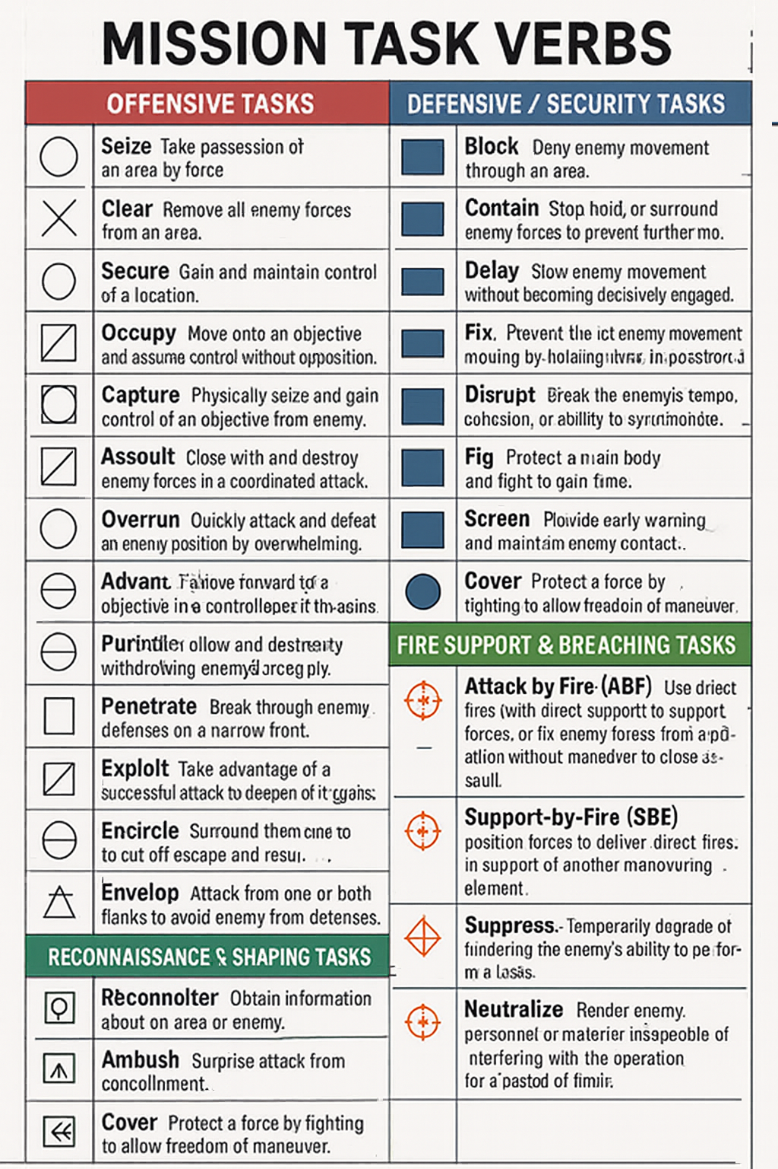

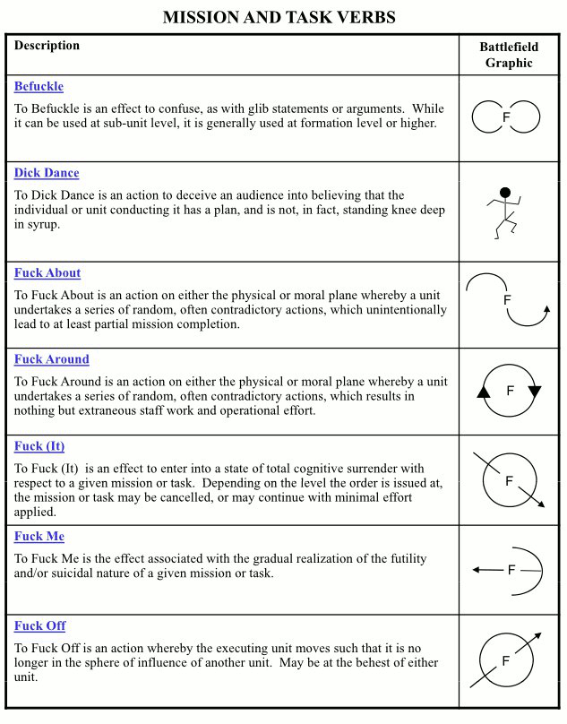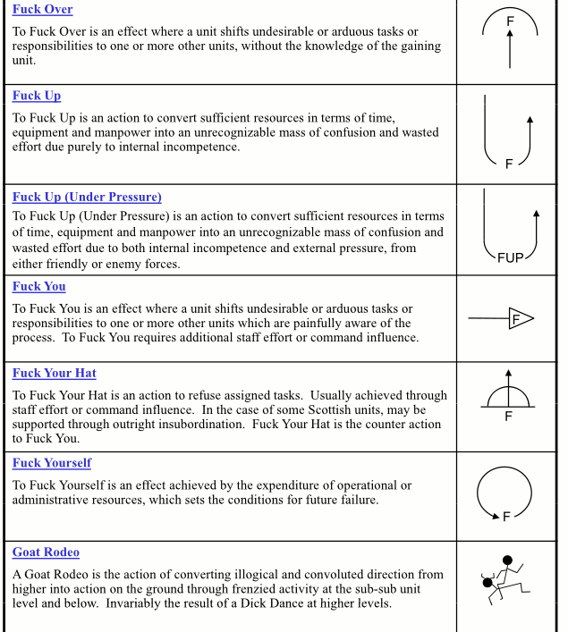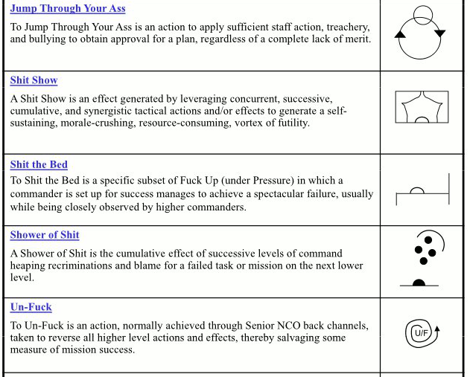

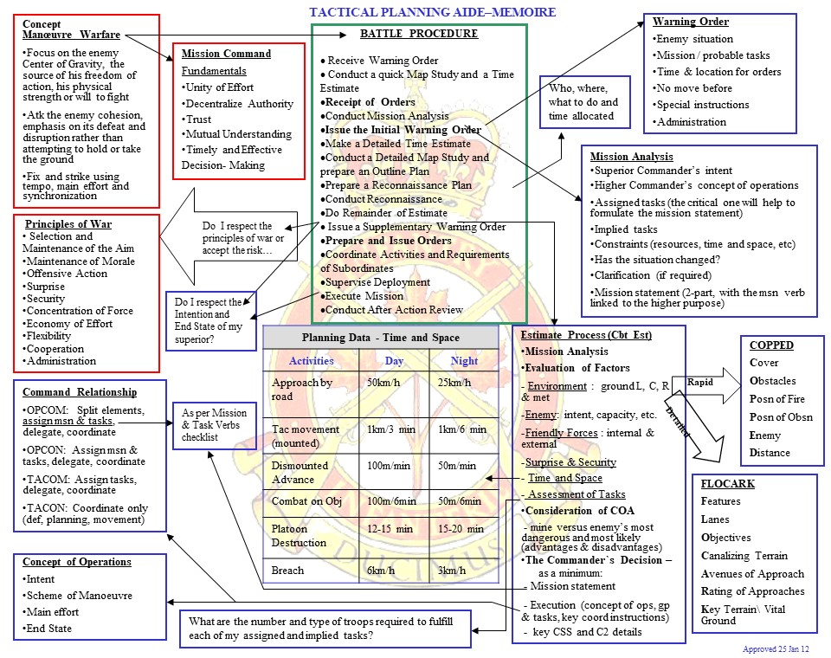

Additional Resources:
https://battlepro.ca/?item=msnTaskVerbs&lastitem=reference&pagetitle=Mission%20Task%20Verbs

